30th January 2022
Press Release n. 11

AAMU - Alpe Adria Motorcycle Union General Assembly
and BMU – Balkan Motorcycle Union meeting in Bucharest

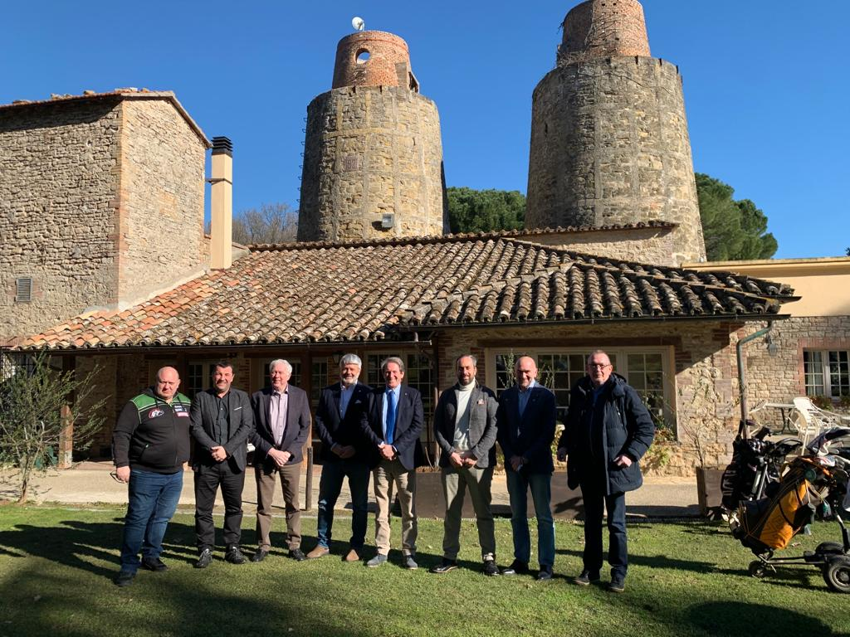

Yesterday 29th January two Regional Associations of FIM Europe organised their General Assembly.

The President Martin de Graaff and the Secretary General Alessandro Sambuco attended the AAMU - Alpe Adria Motorcycle Union General Assembly in Perugia (ITA). At the AAMU GA 9 Federations joined the meeting in presence or by Zoom.
It is good to notice that in 2022 the competition will consist of 5 Championships, Circuit Racing is the most important discipline, besides this Motocross and Extreme Enduro are starting competitions in the coming year.
All management reports and the budget were approved.
The host Federation FMI was represented by the President Giovanni Copioli.

In the break of this meeting the FIM Europe and Alpe Adria Presidents were connected by zoom to the meeting of the BMU – Balkan Motorcycle Union in Bucharest.
In this meeting 7 Federations were present.
The GA elected as new BMU President Ioan Cristian Muresan (FMR). The BMU prepared new Statutes to be approved by the GA.

In March another Regional Association MACEC - Motorcycle Association of Central European Countries will meet.

