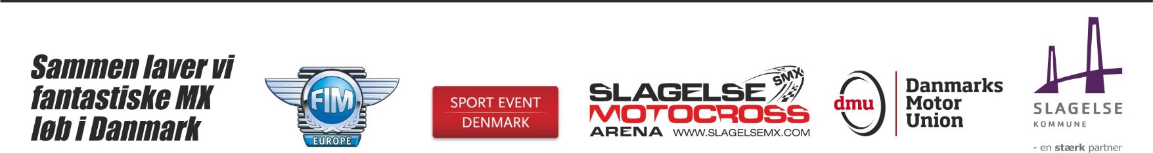
Entry form
2018 Sidecarcross of European Nations
IMN 227/1 - DMU - Slagelse - 22-23.09.2018 (Denmark)

FMN: | Country:

Team A
Rider: | Passenger:
Family Name: | Family Name:
First Name: | First Name:
FNM: | FNM:
License: | License:
Date of Birth: | Date of Birth:
Motorcycle Marque:
Motorcycle Capacity:

Team B
Rider: | Passenger:
Family Name: | Family Name:
First Name: | First Name:
FNM: | FNM:
License: | License:
Date of Birth: | Date of Birth:
Motorcycle Marque:
Motorcycle Capacity:

Team C
Rider: | Passenger:
Family Name: | Family Name:
First Name: | First Name:
FNM: | FNM:
License: | License:
Date of Birth: | Date of Birth:
Motorcycle Marque:
Motorcycle Capacity:

Name of Team Manager:

Participants Responsability et Liability
a) Responsibility
The participants (entrants, drivers, passengers, owners and owner-drivers of vehicles)take part in the event at their own risk. They bear the sole responsability regarding civil and penal codes for damages caused by them or the vehicle in their use of so far as no liability exemption has been stipulated in compliance with the supplementary regulations of the meeting. If the driver, himself, is neither the owner nor the owner- driver of the vehicle used by him during the competition, he releases those persons listed in the following liability waiver from all claims by the owner and the owner-driver of the vehicle or submits, together with the entry form, a corresponding waiver from the owner or the owner- driver of the vehicle.
b) Liability Waiver
By submitting the entry form, the participants (entrants, drivers, passengers, owners and owner-drivers of vehicles) waive all rights to legal action and recourse for any accident or damage incurred in conjuction with the event against:
- the FIM-Europe, the FIM, the FMNR, their presidents, members, employes and officials;
- member-club of the FMNR and their sub-organization;
- organizer/promoter, his/their representatives, stewards and assistants;
- the owner(s) of the property used for the event including structures and installations on it, the administration of the circuit used for the event, its representatives and assistants;
- the participants and their attendants as well as against his/their own assistants in so far as a race or special tests for attaining high-speeds or best times are concerned;
- authorities, race services and any other organization or corporate or natural bodies involved in the organization of the event, in so far as the accident or damage did not occur through intent or gross negligence. This agreement will take effect for all parties involved with the submission of the entry form to the organizer.
The undersigned recognizes the above restrictions and commits himself to comply strictly with them, if an injury occurs or is noticed during the event of if the rider’s health has been affected such that his fitness for continuing in the motorcycling competition has been put in question , the undersigned – with regard to the security risk also resulting for third parties – releases the doctors for their obligation to professional secrecy towards the FMNR and towards the officials carrying responsability at the event (Doctor of the Event, Clerk of the Course, Sporting Stewards) respectively.
Place:
Date:

Rider’s Team A signature
(in case of minor signature of a legal guardian):
Passenger’s Team A signature
(in case of minor signature of a legal guardian):
Rider’s Team B signature (in case of minor signature of a legal guardian):
Passenger’s Team B signature
(in case of minor signature of a legal guardian):
Passenger’s Team B signature
(in case of minor signature of a legal guardian):
Passenger’s Team B signature
(in case of minor signature of a legal guardian):
STARTING PERMISSION GRANTED

Stamp & signature of the FMN

